Introduction

This document is intended for developers who would like to understand the structure of our project, and would like to improve our solution
- The first part describes the principle of our solution through the execution of a simple case.
- The second one gives an overview of the java architecture of the project and the jax-rs elements which are used, with references to the corresponding documentation
- As we know our solution can be improved, we also wrote a few lines about what could be added to our solution on future projects
- The document ends with references to the libraries and documentations used in the project

Contents

I) Description of the solution
II) Overview of the architecture
III) Improvements
IV) Libraries

I) Description of the solution

- General description

As described in the motivation report, the idea of our project is to allow the subsomption principle in CXF. As we wanted to offer a solution without modifying the framework, we chose to use an element of the JAX-RS architecture : filters. The latter can be used to intercept a request to the server or a response to a client, and to modify the entity which is being streamed (i.e. the xml representation of the object contained in a request/response). Once the entity is intercepted, we modify it so that the subsomption principle is respected.

- Two kinds of workflow

Our solution can be used either when a request is sent to the server, or for a response to the server. In both case the CXF framework raises exception showing that the subsomption principle is not respected. Even if the low level algorithms are the same for both cases, the higher levels of the algorithm are slightly different. The next paragraphs illustrate this :

As a reminder, here are the cases when the subsomption principle is not respected in CXF (more details in the motivation report) :
- Case request: When a request is sent to the server : the server has a method which is waiting for an object of class A. The client sends an object of class B to the method, subclass of A, unknown server side. A bug is raised.
- Case response: For a response from the server to the client : first the server is supposed to send an object of class A. The client has a proxy representing the service, and expects an object of class A. The server is then modified and is supposed to send an object of class B, subclass of A. The client then calls the method. As B extends A, the subsomption principle should apply, although we might expect an exception since we changed the service without notifying the client.

Here is the description of the workflow of our solution for both cases :
Case request :

A request is sent to the server → The filter intercepts the request → The entity is converted to a Document →The entity is compared to the arguments of the service → The entity is modified to be converted to a document representing the class expected by the server

Case response :
A response is sent to the client → The filter intercepts the request → The entity is converted to a Doucment¹→ The entity is compared to the return type of the method of the service proxy→ The entity is modified to be converted to a document representing the class of the return type of the service proxy

II) Overview of the architecture

Our solution can be applied either client side or server side, depending on the case to be corrected (case request or response described on part I). The architectures are slighty different depending on which part (client or server) they are used, as you could expect after reading part I about the workflow.

1) Solution for case request : a request to the server

The following diagram describes the packages of our project :

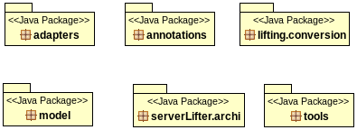

- serverLifter.archi contains the classes used for the low level algorithms, i.e. those which modify the xml representation of an object, to make it correspond to what is expected by the arguments of the service method.
- lifting.conversion is the package for classes which converts the streams of data into java xml representation.
- adapters package contains classes which are necessary when the xml entity is compared with an interface. In this case, we have to know at runtime which implementation our xml entity must be compared with.
- annotations contain the annotations that user can apply on a service method to run our algorithm
- tools contains functionalities that are not directly linked with the implementation of our solution. To date, it contains a method which provides a static toString method for any object.
- model is the package for classes used in tests (service, simple java models). It contains very simple representations which can be used to show what our solution is bringing to CXF framework.

2) Solution for case response : a response is sent to the client

The package diagram is as follows :

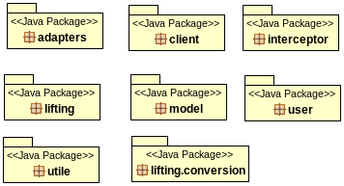

- lifing : is equivalent to the serverLifter.archi server side, with adapted classes for the client.
- lifting.conversion : contains exactly the same classes as lifting.conversion for the server project.
- adapters : equivalent to adapter for the server
-

Using JDom2 library. See
Using JDom2 library

